|  |  |
| --- | --- |
| [COS10011] Assignment 2 Report | Version: 1.0 |
| Team Name: Amazing Retard | Date: [2018-05-06] |
| Title: RV Rental Company | |

# Introduction

The objective of this assignment is to make an extension to the website created in assignment 1 by adding links/buttons/icon to each products/service offered by the website to ease users to send an enquiry regarding a product or services and validate the data entered by the users before the form is submit.

# JavaScript

## Data Transfer between Web pages

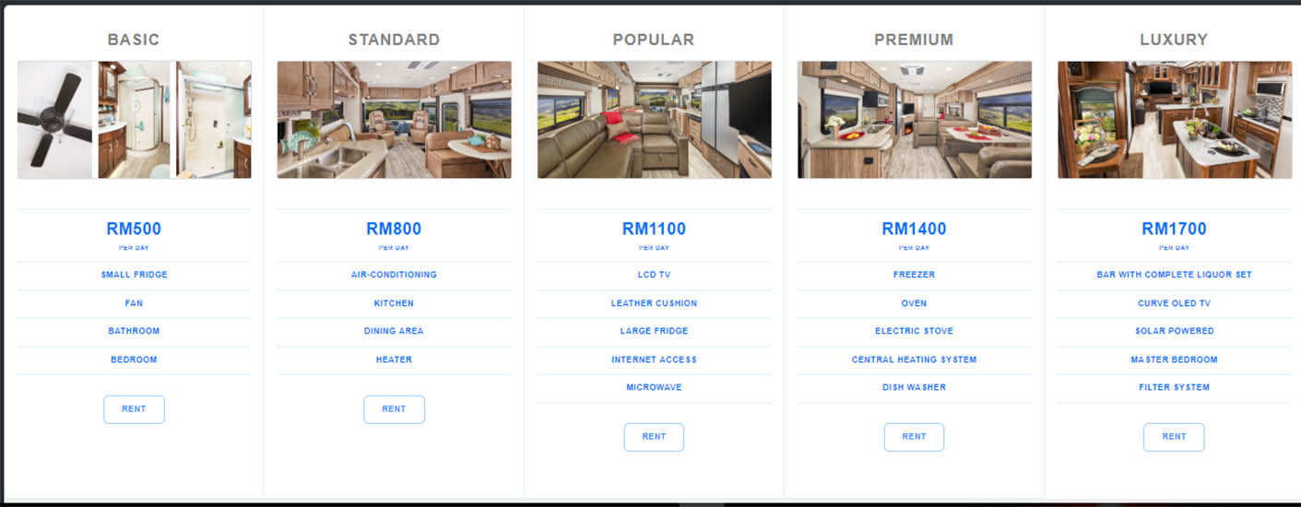

Figure Rental page selection

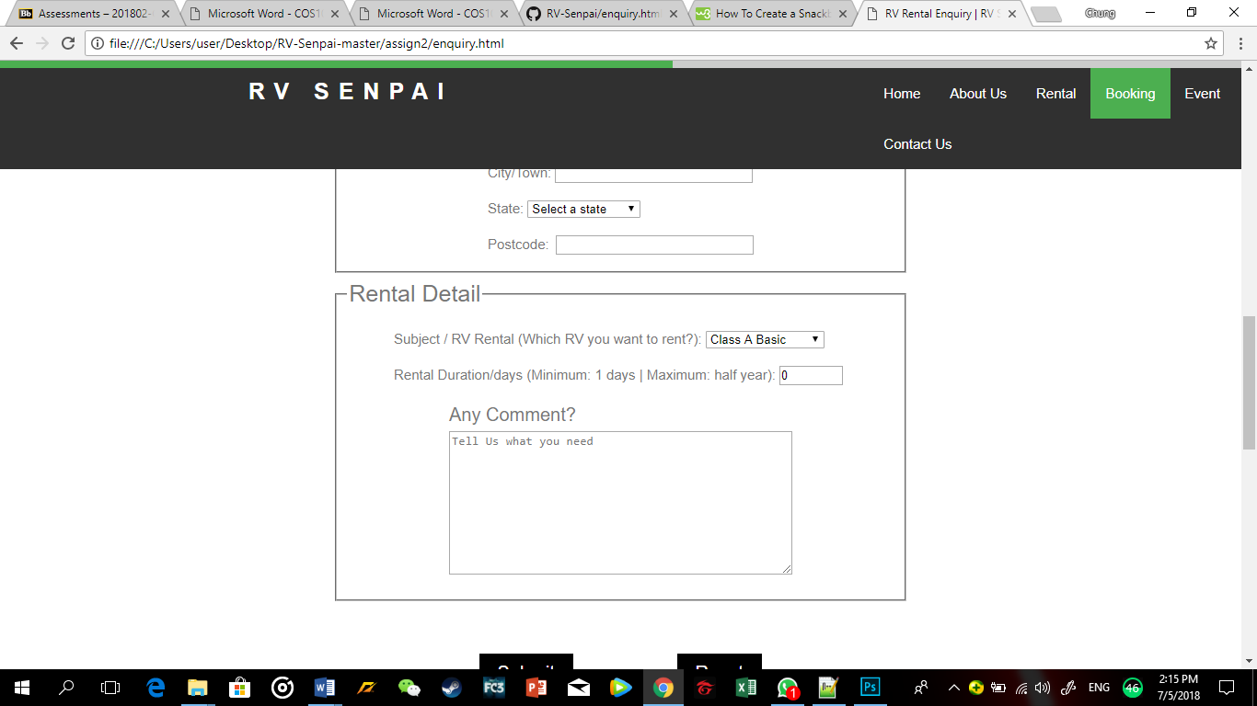

Figure Data transfer to enquiry form

This part is implemented in the Product page, when the user selects to rent a certain product, the selection will appear in the product selection on the rental enquiry form in the rental enquiry page.

## Data Transfer in the same page

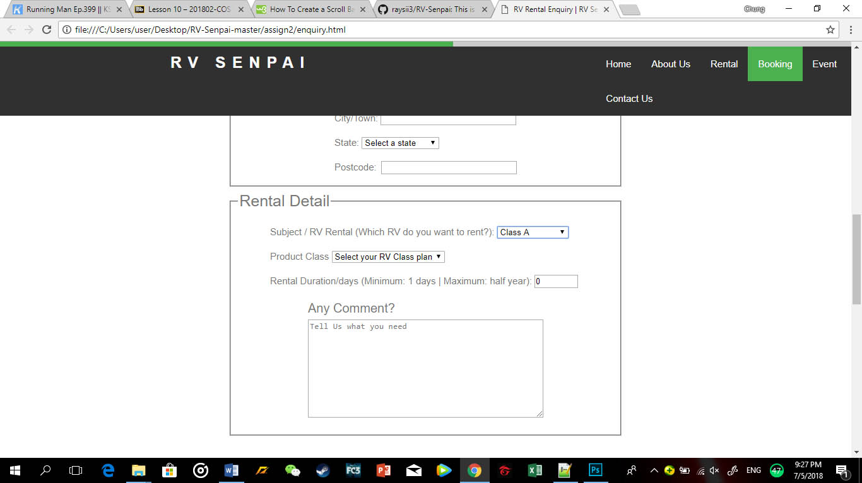

Figure Data transfer in the same page

This function is implement in the rental enquiry page of the website. It will transfer the class of the selected product type to another selection list.

## Data Validation and Checking of Forms

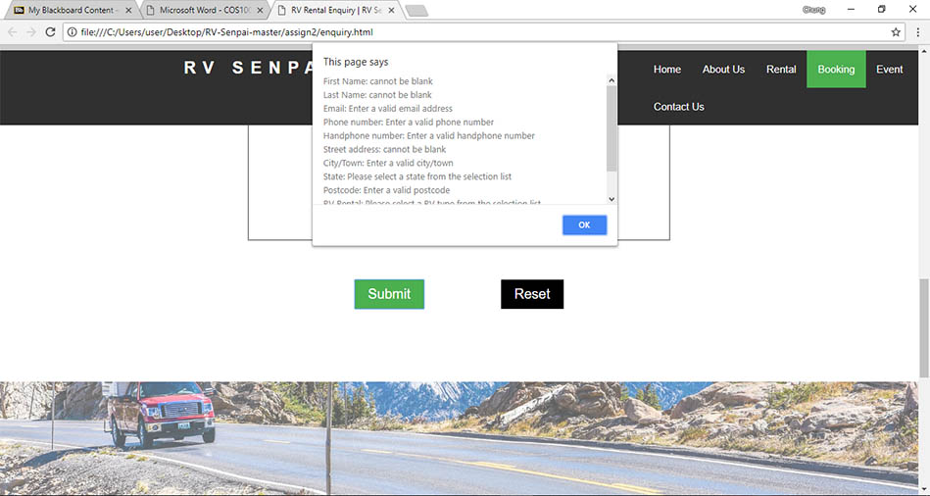

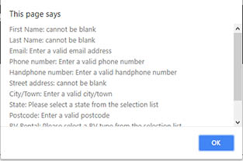

Figure Form data validation

In this part of the assignment, we have demonstrated different techniques on using Javascript client-side validation to validate the data that users enter into the form in the enquiry.html page. The browser will display a window dialog as shown above to alert the user that there are errors in the data entered in the form.

## Populate drop-down list using Javascript

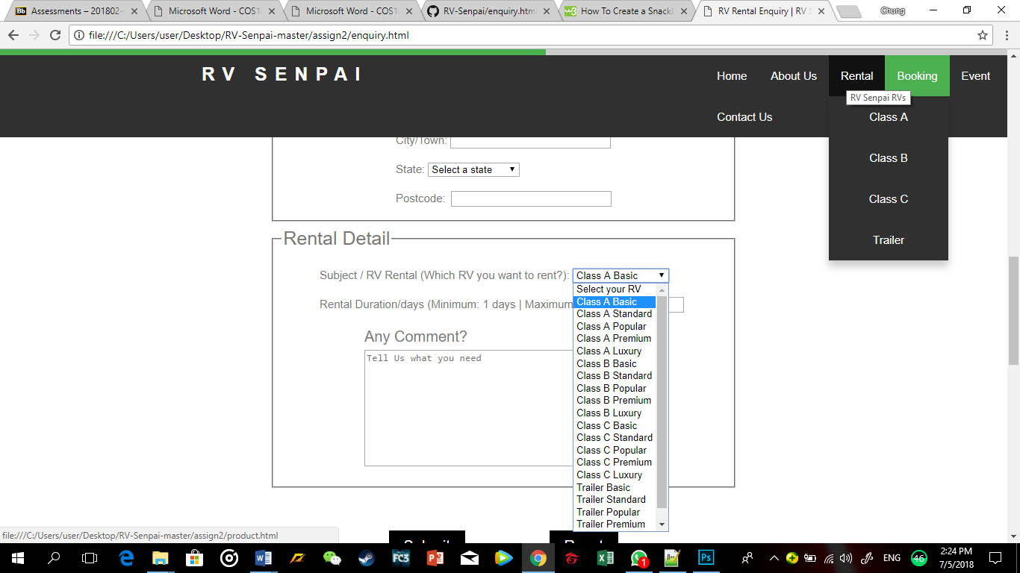

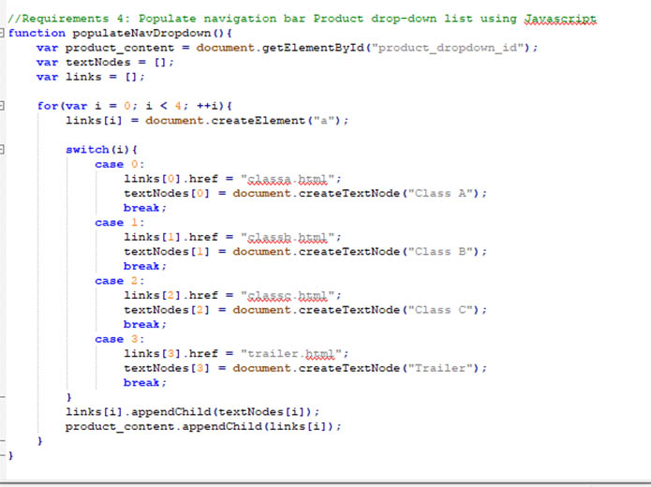

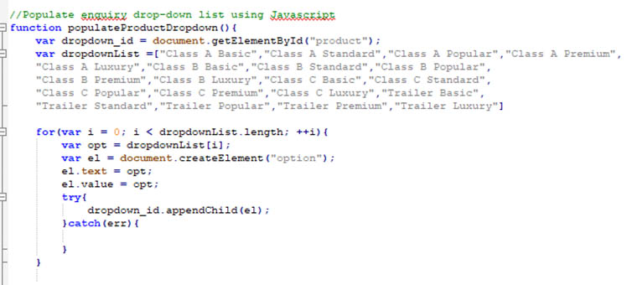

Figure Populate drop-down list with javascript

This part of the assignment is implemented in the product link in the navigation bar and the drop-down selection list in the rental enquiry form.

# Enhancement

## Image Grid

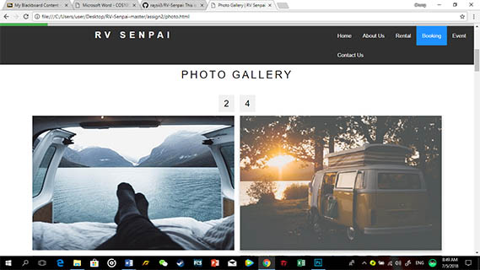

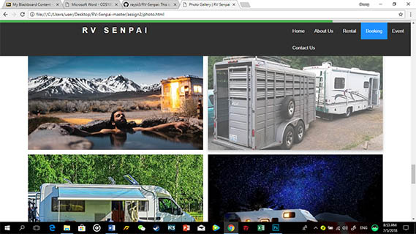

Figure Image grid

This enhancement.js are put inside the script folder. This enhancement uses for loop function that count the amount of div class column which is 4. The flex has set the length of the class to 50% so that it would fit in the webpage nicely.

## Scroll Indicator effect

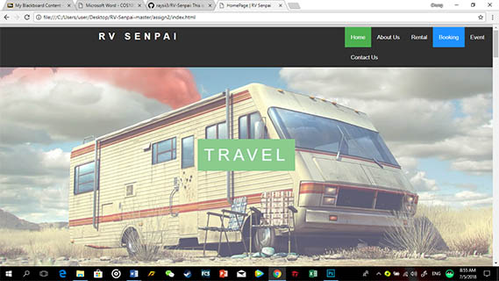

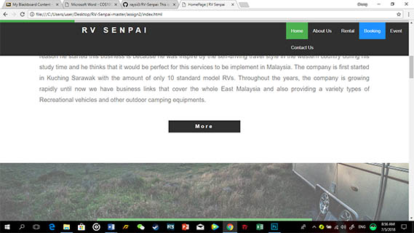

Scroll Indicator

Figure Scroll Indicator

This enhancement is available in all the web page of the website. To have the scroll effect, the height of the individual webpage must be considered. And according to the webpage height, percentage of scrolled will be included and be display as an indicator to indicate the webpage scrolled.

## Event Count Down

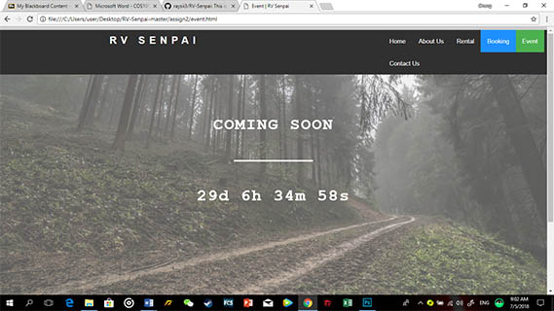

Figure event count-down

This enhancement is only available in the Event page of the website. Date, hours, minutes, and seconds variable are declared, and a calculation function is written to calculate the current date and display the incoming date on the webpage.

## Modal Image Gallery / Lightbox

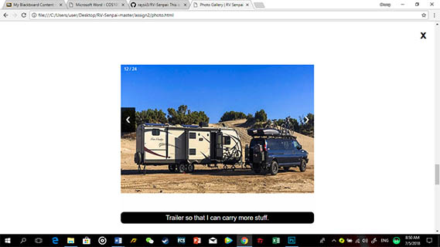

Figure Light Box

This Javascript effect is used in the Photo Gallery page of the website. This enhancement is to show the modal image gallery or lightbox for the page. The div elements with class row is for the user to click and then display the lightbox. While div element with column is the image that will show in the lightbox. Variable captionText in the enhancement is to show the caption of the image. There are also a next and previous button available to navigate user to the next or previous picture. A close button also available for users to exit the lightbox.

## Back to top Button

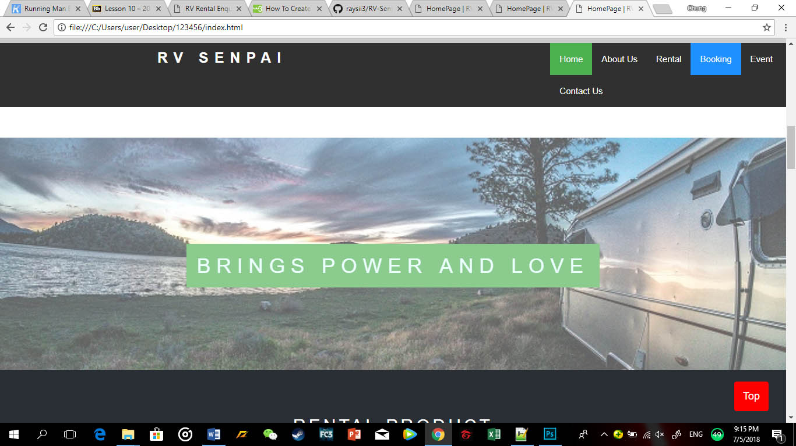

Figure Back to top button

This button is available in all the webpage, it enables user to instantly navigate the users back to the top of the webpage rather than scrolling all the way back to the top.

# Member Contribution

|  |  |
| --- | --- |
| **Team Member 1** | **Ericson** |
| **Contribution (%)** | **25%** |
| **List of Contribution** | **Scroll Indicator (Enhancement), Event Countdown (Enhancement), HTML, CSS** |
|  |  |

|  |  |
| --- | --- |
| **Team Member 2** | **Ian** |
| **Contribution (%)** | **25%** |
| **List of Contribution** | **Data validation and input checking of form, Report generating, HTML, CSS** |
|  |  |

|  |  |
| --- | --- |
| **Team Member 3** | **Raymond** |
| **Contribution (%)** | **25%** |
| **List of Contribution** | **Data transfer between webpages, Data transfer in the same page, Populate drop-down list, HTML, CSS** |
|  |  |

|  |  |
| --- | --- |
| **Team Member 4** | **Loo** |
| **Contribution (%)** | **25%** |
| **List of Contribution** | **Photo Gallery (Enhancement), Lightbox (Enhancement), HTML, CSS** |
|  |  |

# Group Reflection

The challenge that we face during the progress of this assignment is there are limited time provides for the team to complete the task and requirements as all the members are working with other assignments at the same time.

Besides that, the team also faces slightly hardship in figuring the algorithm of writing the Javascript function. For example, some enhancement in the website is outside the learning syllabus so the team must do self-study to understand the algorithm such as the lightbox, scroll indicator, and snackbar are all out of our learning syllabus, so we must refer to reference from W3School to complete the task.

We also realise that it is important for us to work as a team, this is because everyone of us has our own advantages and shortage for example Raymond and Ericson are more experienced in doing javascript while Ian and Loo are better in doing layout and brainstorming for ideas.

In conclusion, we can say that we are still a long way to go to develop a strong and high-end website.